# A16 程序基本结构与编译运行

## 教学目标

## 理解程序的基本结构，理解程序编译运行的基本原理与过程

## 教学内容

1. 理解程序基本结构，理解预处理语句、命名空间等概念，完全掌握程序基本结构的写法
2. 理解程序编译运行原理与过程

## 课后作业

探究性问题：请用程序探索质数的分布规律，把10000以内（不包括10000）的正整数，每100个数编为一组，统计计算看每一组内质数的个数是否有明显的规律性特征。（按0-99,100-199,200-299分组）

（答案：见本文件末尾，请家长督促完成后检查，或老师第二次课时检查）

## 成果展示

（截图／单独的文件或网址分享，请直接复制到微信等发送给家长）

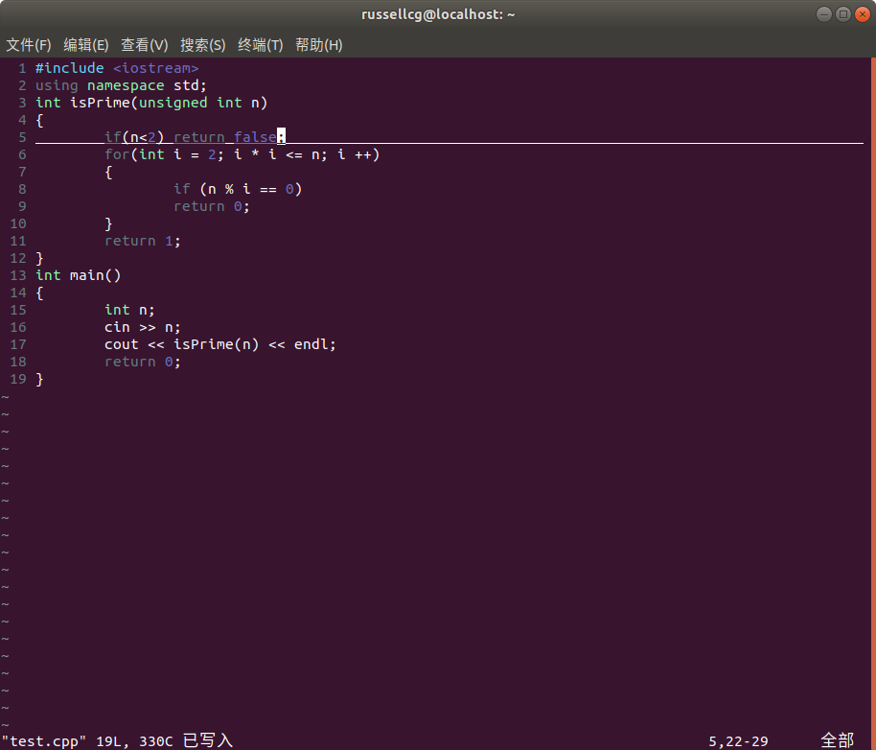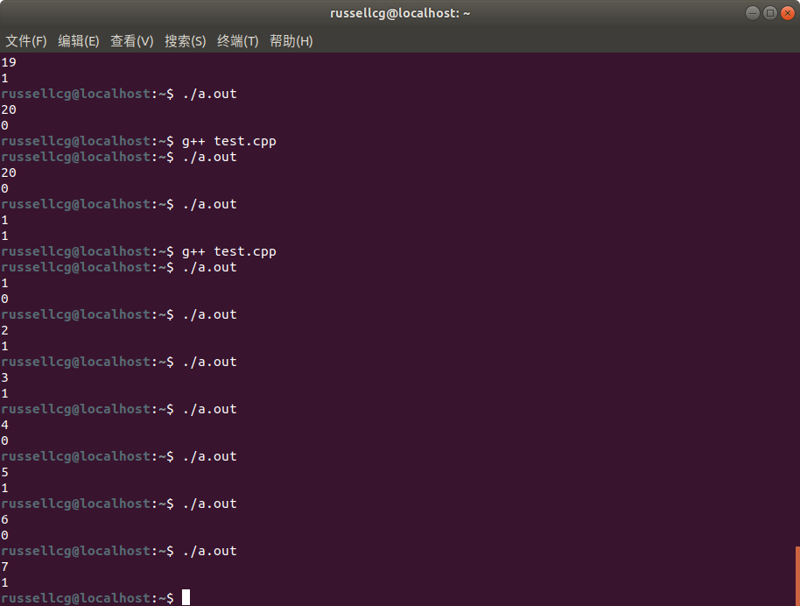

## 课件作业参考答案：

1 #include <iostream>

2 using namespace std;

3 int isPrime(unsigned int n)

4 {

5 if(n<2) return false;

6 for(int i = 2; i * i <= n; i ++)

7 {

8 if (n % i == 0)

9 return 0;

10 }

11 return 1;

12 }

13 int main()

14 {

15 int n = 0, m = 10000, c;

16 while(n<m)

17 {

18 cout << "from " << n << " to " << (n+100) << ": ";

19 c=0;

20 for (int i=n+0; i!= n+100; i++)

21 if(isPrime(i))

22 {

23 cout << i << " ";

24 c++;

25 }

26 n+=100;

27 cout << endl << "total: " << c << endl;

28 }

29 return 0;

30 }

## 统计数据：

from 0 to 100: 2 3 5 7 11 13 17 19 23 29 31 37 41 43 47 53 59 61 67 71 73 79 83 89 97

total: 25

from 100 to 200: 101 103 107 109 113 127 131 137 139 149 151 157 163 167 173 179 181 191 193 197 199

total: 21

from 200 to 300: 211 223 227 229 233 239 241 251 257 263 269 271 277 281 283 293

total: 16

from 300 to 400: 307 311 313 317 331 337 347 349 353 359 367 373 379 383 389 397

total: 16

from 400 to 500: 401 409 419 421 431 433 439 443 449 457 461 463 467 479 487 491 499

total: 17

from 500 to 600: 503 509 521 523 541 547 557 563 569 571 577 587 593 599

total: 14

from 600 to 700: 601 607 613 617 619 631 641 643 647 653 659 661 673 677 683 691

total: 16

from 700 to 800: 701 709 719 727 733 739 743 751 757 761 769 773 787 797

total: 14

from 800 to 900: 809 811 821 823 827 829 839 853 857 859 863 877 881 883 887

total: 15

from 900 to 1000: 907 911 919 929 937 941 947 953 967 971 977 983 991 997

total: 14

from 1000 to 1100: 1009 1013 1019 1021 1031 1033 1039 1049 1051 1061 1063 1069 1087 1091 1093 1097

total: 16

from 1100 to 1200: 1103 1109 1117 1123 1129 1151 1153 1163 1171 1181 1187 1193

total: 12

from 1200 to 1300: 1201 1213 1217 1223 1229 1231 1237 1249 1259 1277 1279 1283 1289 1291 1297

total: 15

from 1300 to 1400: 1301 1303 1307 1319 1321 1327 1361 1367 1373 1381 1399

total: 11

from 1400 to 1500: 1409 1423 1427 1429 1433 1439 1447 1451 1453 1459 1471 1481 1483 1487 1489 1493 1499

total: 17

from 1500 to 1600: 1511 1523 1531 1543 1549 1553 1559 1567 1571 1579 1583 1597

total: 12

from 1600 to 1700: 1601 1607 1609 1613 1619 1621 1627 1637 1657 1663 1667 1669 1693 1697 1699

total: 15

from 1700 to 1800: 1709 1721 1723 1733 1741 1747 1753 1759 1777 1783 1787 1789

total: 12

from 1800 to 1900: 1801 1811 1823 1831 1847 1861 1867 1871 1873 1877 1879 1889

total: 12

from 1900 to 2000: 1901 1907 1913 1931 1933 1949 1951 1973 1979 1987 1993 1997 1999

total: 13

from 2000 to 2100: 2003 2011 2017 2027 2029 2039 2053 2063 2069 2081 2083 2087 2089 2099

total: 14

from 2100 to 2200: 2111 2113 2129 2131 2137 2141 2143 2153 2161 2179

total: 10

from 2200 to 2300: 2203 2207 2213 2221 2237 2239 2243 2251 2267 2269 2273 2281 2287 2293 2297

total: 15

from 2300 to 2400: 2309 2311 2333 2339 2341 2347 2351 2357 2371 2377 2381 2383 2389 2393 2399

total: 15

from 2400 to 2500: 2411 2417 2423 2437 2441 2447 2459 2467 2473 2477

total: 10

from 2500 to 2600: 2503 2521 2531 2539 2543 2549 2551 2557 2579 2591 2593

total: 11

from 2600 to 2700: 2609 2617 2621 2633 2647 2657 2659 2663 2671 2677 2683 2687 2689 2693 2699

total: 15

from 2700 to 2800: 2707 2711 2713 2719 2729 2731 2741 2749 2753 2767 2777 2789 2791 2797

total: 14

from 2800 to 2900: 2801 2803 2819 2833 2837 2843 2851 2857 2861 2879 2887 2897

total: 12

from 2900 to 3000: 2903 2909 2917 2927 2939 2953 2957 2963 2969 2971 2999

total: 11

from 3000 to 3100: 3001 3011 3019 3023 3037 3041 3049 3061 3067 3079 3083 3089

total: 12

from 3100 to 3200: 3109 3119 3121 3137 3163 3167 3169 3181 3187 3191

total: 10

from 3200 to 3300: 3203 3209 3217 3221 3229 3251 3253 3257 3259 3271 3299

total: 11

from 3300 to 3400: 3301 3307 3313 3319 3323 3329 3331 3343 3347 3359 3361 3371 3373 3389 3391

total: 15

from 3400 to 3500: 3407 3413 3433 3449 3457 3461 3463 3467 3469 3491 3499

total: 11

from 3500 to 3600: 3511 3517 3527 3529 3533 3539 3541 3547 3557 3559 3571 3581 3583 3593

total: 14

from 3600 to 3700: 3607 3613 3617 3623 3631 3637 3643 3659 3671 3673 3677 3691 3697

total: 13

from 3700 to 3800: 3701 3709 3719 3727 3733 3739 3761 3767 3769 3779 3793 3797

total: 12

from 3800 to 3900: 3803 3821 3823 3833 3847 3851 3853 3863 3877 3881 3889

total: 11

from 3900 to 4000: 3907 3911 3917 3919 3923 3929 3931 3943 3947 3967 3989

total: 11

from 4000 to 4100: 4001 4003 4007 4013 4019 4021 4027 4049 4051 4057 4073 4079 4091 4093 4099

total: 15

from 4100 to 4200: 4111 4127 4129 4133 4139 4153 4157 4159 4177

total: 9

from 4200 to 4300: 4201 4211 4217 4219 4229 4231 4241 4243 4253 4259 4261 4271 4273 4283 4289 4297

total: 16

from 4300 to 4400: 4327 4337 4339 4349 4357 4363 4373 4391 4397

total: 9

from 4400 to 4500: 4409 4421 4423 4441 4447 4451 4457 4463 4481 4483 4493

total: 11

from 4500 to 4600: 4507 4513 4517 4519 4523 4547 4549 4561 4567 4583 4591 4597

total: 12

from 4600 to 4700: 4603 4621 4637 4639 4643 4649 4651 4657 4663 4673 4679 4691

total: 12

from 4700 to 4800: 4703 4721 4723 4729 4733 4751 4759 4783 4787 4789 4793 4799

total: 12

from 4800 to 4900: 4801 4813 4817 4831 4861 4871 4877 4889

total: 8

from 4900 to 5000: 4903 4909 4919 4931 4933 4937 4943 4951 4957 4967 4969 4973 4987 4993 4999

total: 15

from 5000 to 5100: 5003 5009 5011 5021 5023 5039 5051 5059 5077 5081 5087 5099

total: 12

from 5100 to 5200: 5101 5107 5113 5119 5147 5153 5167 5171 5179 5189 5197

total: 11

from 5200 to 5300: 5209 5227 5231 5233 5237 5261 5273 5279 5281 5297

total: 10

from 5300 to 5400: 5303 5309 5323 5333 5347 5351 5381 5387 5393 5399

total: 10

from 5400 to 5500: 5407 5413 5417 5419 5431 5437 5441 5443 5449 5471 5477 5479 5483

total: 13

from 5500 to 5600: 5501 5503 5507 5519 5521 5527 5531 5557 5563 5569 5573 5581 5591

total: 13

from 5600 to 5700: 5623 5639 5641 5647 5651 5653 5657 5659 5669 5683 5689 5693

total: 12

from 5700 to 5800: 5701 5711 5717 5737 5741 5743 5749 5779 5783 5791

total: 10

from 5800 to 5900: 5801 5807 5813 5821 5827 5839 5843 5849 5851 5857 5861 5867 5869 5879 5881 5897

total: 16

from 5900 to 6000: 5903 5923 5927 5939 5953 5981 5987

total: 7

from 6000 to 6100: 6007 6011 6029 6037 6043 6047 6053 6067 6073 6079 6089 6091

total: 12

from 6100 to 6200: 6101 6113 6121 6131 6133 6143 6151 6163 6173 6197 6199

total: 11

from 6200 to 6300: 6203 6211 6217 6221 6229 6247 6257 6263 6269 6271 6277 6287 6299

total: 13

from 6300 to 6400: 6301 6311 6317 6323 6329 6337 6343 6353 6359 6361 6367 6373 6379 6389 6397

total: 15

from 6400 to 6500: 6421 6427 6449 6451 6469 6473 6481 6491

total: 8

from 6500 to 6600: 6521 6529 6547 6551 6553 6563 6569 6571 6577 6581 6599

total: 11

from 6600 to 6700: 6607 6619 6637 6653 6659 6661 6673 6679 6689 6691

total: 10

from 6700 to 6800: 6701 6703 6709 6719 6733 6737 6761 6763 6779 6781 6791 6793

total: 12

from 6800 to 6900: 6803 6823 6827 6829 6833 6841 6857 6863 6869 6871 6883 6899

total: 12

from 6900 to 7000: 6907 6911 6917 6947 6949 6959 6961 6967 6971 6977 6983 6991 6997

total: 13

from 7000 to 7100: 7001 7013 7019 7027 7039 7043 7057 7069 7079

total: 9

from 7100 to 7200: 7103 7109 7121 7127 7129 7151 7159 7177 7187 7193

total: 10

from 7200 to 7300: 7207 7211 7213 7219 7229 7237 7243 7247 7253 7283 7297

total: 11

from 7300 to 7400: 7307 7309 7321 7331 7333 7349 7351 7369 7393

total: 9

from 7400 to 7500: 7411 7417 7433 7451 7457 7459 7477 7481 7487 7489 7499

total: 11

from 7500 to 7600: 7507 7517 7523 7529 7537 7541 7547 7549 7559 7561 7573 7577 7583 7589 7591

total: 15

from 7600 to 7700: 7603 7607 7621 7639 7643 7649 7669 7673 7681 7687 7691 7699

total: 12

from 7700 to 7800: 7703 7717 7723 7727 7741 7753 7757 7759 7789 7793

total: 10

from 7800 to 7900: 7817 7823 7829 7841 7853 7867 7873 7877 7879 7883

total: 10

from 7900 to 8000: 7901 7907 7919 7927 7933 7937 7949 7951 7963 7993

total: 10

from 8000 to 8100: 8009 8011 8017 8039 8053 8059 8069 8081 8087 8089 8093

total: 11

from 8100 to 8200: 8101 8111 8117 8123 8147 8161 8167 8171 8179 8191

total: 10

from 8200 to 8300: 8209 8219 8221 8231 8233 8237 8243 8263 8269 8273 8287 8291 8293 8297

total: 14

from 8300 to 8400: 8311 8317 8329 8353 8363 8369 8377 8387 8389

total: 9

from 8400 to 8500: 8419 8423 8429 8431 8443 8447 8461 8467

total: 8

from 8500 to 8600: 8501 8513 8521 8527 8537 8539 8543 8563 8573 8581 8597 8599

total: 12

from 8600 to 8700: 8609 8623 8627 8629 8641 8647 8663 8669 8677 8681 8689 8693 8699

total: 13

from 8700 to 8800: 8707 8713 8719 8731 8737 8741 8747 8753 8761 8779 8783

total: 11

from 8800 to 8900: 8803 8807 8819 8821 8831 8837 8839 8849 8861 8863 8867 8887 8893

total: 13

from 8900 to 9000: 8923 8929 8933 8941 8951 8963 8969 8971 8999

total: 9

from 9000 to 9100: 9001 9007 9011 9013 9029 9041 9043 9049 9059 9067 9091

total: 11

from 9100 to 9200: 9103 9109 9127 9133 9137 9151 9157 9161 9173 9181 9187 9199

total: 12

from 9200 to 9300: 9203 9209 9221 9227 9239 9241 9257 9277 9281 9283 9293

total: 11

from 9300 to 9400: 9311 9319 9323 9337 9341 9343 9349 9371 9377 9391 9397

total: 11

from 9400 to 9500: 9403 9413 9419 9421 9431 9433 9437 9439 9461 9463 9467 9473 9479 9491 9497

total: 15

from 9500 to 9600: 9511 9521 9533 9539 9547 9551 9587

total: 7

from 9600 to 9700: 9601 9613 9619 9623 9629 9631 9643 9649 9661 9677 9679 9689 9697

total: 13

from 9700 to 9800: 9719 9721 9733 9739 9743 9749 9767 9769 9781 9787 9791

total: 11

from 9800 to 9900: 9803 9811 9817 9829 9833 9839 9851 9857 9859 9871 9883 9887

total: 12

from 9900 to 10000: 9901 9907 9923 9929 9931 9941 9949 9967 9973

total: 9